**Mini Project Report on**



**VEHICLE DETECTION AND COUNTING**



**Submitted in partial fulfillment of the requirement for the award of the degree of**

**BACHELOR OF TECHNOLOGY**

**IN**

**COMPUTER SCIENCE & ENGINEERING**

**Submitted by:**

**Student Name: PRERANA University Roll No.: 2118930**



**Department of Computer Science and Engineering**

**Graphic Era Hill University**

**Dehradun, Uttarakhand**



**CANDIDATE’S DECLARATION**

I hereby certify that the work which is being presented in the project report entitled **“VEHICLE DETECTION AND COUNTING”** in partial fulfillment of the requirements for the award of the Degree of Bachelor of Technology in Computer Science and Engineeringof the Graphic Era Hill University, Dehradun shall be carried out by myself under the mentorship of **Mr. Akash Chauhan, Assistant Professor**, Department of Computer Science and Engineering, Graphic Era Hill University, Dehradun.

**Name: PRERANA University Roll no.: 2118930**

**Table of Contents**

|  |  |  |
| --- | --- | --- |
| **Chapter No.** | **Description** | **Page No.** |
| Chapter 1 | Introduction | 1-3 |
| Chapter 2 | Literature Survey | 4-5 |
| Chapter 3 | Methodology | 6-8 |
| Chapter 4 | Result and Discussion | 9-10 |
| Chapter 5 | Conclusion and Future Work | 11 |
|  | References | 12 |

**Chapter 1**

**Introduction**

* 1. **Introduction**

With the exponential increase in traffic on the roadways nowadays, traffic management has become a crucial daily routine in cities. detection of vehicles automatically

Better traffic management on congested roads and road crossings can be achieved by analysing traffic scenes and extracting key information relating to vehicle traffic. Sensors [1, 2] and image processing methods can both be used to monitor traffic flow and calculate traffic metrics.

Automated traffic management is one of a smart city's essential elements. And that got me to wondering: could I leverage my expertise in data science to create a vehicle recognition model that could contribute to smart traffic management?

Consider how easy you could monitor a variety of valuable things at once if you could incorporate a vehicle detection system into a traffic light camera:

* How many cars are in the intersection of the road during the day?
* When does the traffic start to get heavy?
* What kinds of vehicles (heavy vehicles, autos, etc.) are passing through the intersection?
* Is it possible to distribute the traffic through a separate roadway in order to maximise efficiency?

so forth, there are countless applications!

The use of image processing techniques for automatic vehicle detection has been the subject of numerous research papers in the past. The goal of this research was to examine how well the system performed at classifying and counting moving automobiles in a traffic scene within a certain time frame.

In a split second, we humans can quickly locate and identify items in challenging scenes. However, in order to automate that process, we must master the technique of object detection utilising computer vision algorithms.

The needed processing steps are as follows:

* Reducing a video stream to a series of individual frames.
* Separating a steady image from a backdrop image that is changing dynamically.
* The camera has been calibrated.
* Vehicle identification.
* Following moving cars in every lane.
* Vehicle classification and vehicle tally.
  1. **Problem Statement**

In this project, we want to develop open-source video analysis software that would lower the cost of data acquisition and, consequently, enable the timely acquisition of more data regarding traffic flow.

In the end, we hope to create algorithms that could be used on compact, affordable embedded smart camera systems to offer real-time data about hundreds of intersections and provide city operators and traffic planners with a previously unheard-of level of traffic situational awareness.

* 1. **Objectives of the Project**

It is normal practise to conduct traffic analysis studies to provide policy makers with information on the pace of traffic flow and the predominant traffic patterns at important crossings. The temporary deployment of a video camera to capture footage over the course of the study is a frequent method for carrying out similar investigations in urban settings, such as Philadelphia. The routes that vehicles took at the intersection during that time period are then determined by analysing the video.

**Chapter 2**

**Literature Survey**

A method for the detection and classification of vehicles is described in reference [3]. To distinguish the background from the vehicles, it employs a self-adaptive background subtraction algorithm. A spatial matching technique is then used to monitor the related regions throughout a series of photos. Vehicles are created by combining the tracked regions. Reference [4] employs the same method of adaptive backdrop detection for vehicle identification.

A feature-based tracking method has been utilised in reference [5]. The parameters such as line correspondences for a projective mapping, detecting region, and numerous fiducially points for camera stabilisation have been detected using offline camera calibration. Since the features are tracked in world coordinates in order to take advantage of understood physical restrictions on vehicle motion, projective transformation is required in this case.

Position, velocity, and density are distance-based measurements that can be calculated using the transformation. Adaptive background learning for vehicle detection and spatio-temporal tracking is discussed in reference [6]. Unsupervised vehicle detection and spatio-temporal tracking, along with image/video segmentation, background learning/subtraction, and object tracking algorithms, are offered as a framework for the analysis of traffic video sequences. A system on vehicle detection under both day and night lighting is presented in reference [7]. Vehicle detection throughout the day is carried out by detecting moving points using the successive three frame subtraction approach.

The moving objects are categorised as vehicles and given that name. At night, automobiles are detected by recognising them by their pair of headlights. The system uses morphological analysis to recognise only objects with headlights by taking into consideration factors including shape, size, and the minimum distance between vehicles. Last but not least, the verification is based on the correlation of headlights from the same pair. A method for quick vehicle detection with probabilistic feature grouping and its use for vehicle tracking are described in reference [8].In order to prevent vehicle overlapping, three cameras were put on the roof of a 30-story building next to a motorway. The system presents a novel method for tracking moving objects based on a model-based algorithm for 3-D vehicle detection and description. To identify cars, the suggested system employs a probabilistic "line" feature grouping technique. Based on the zero-mean cross correlation matching method, tracking is carried out.

The system tracks the detected cars based on their intensity profiles after detecting them in the entrance area.

**Chapter 3**

**Methodology**

We have tested a variety of methods for handling the video analysis challenge throughout the course of this research. This problem is difficult because of a variety of circumstances. First, we must separate automobiles from the road and from one another in order to count them accurately. Second, the system must continuously and correctly track each vehicle, including stops, starts, and turns. The issue is greatly made more difficult by the traffic camera's non-nadir perspective. First, as they pass through the scene, automobiles can and will obstruct one another. Second, when the vehicles move around the scene, perspective effects make them to grow and shrink in the image.Finally, the software must deal with a significant source of error: shadows and other obtrusive elements.

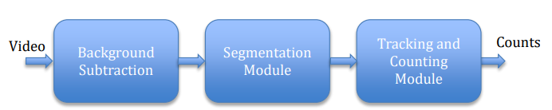

Fig.3.1 Basic Model For Vehicle Detection

The system is broken down into three fundamental stages: a background removal system that recognises conspicuous areas in the image; a segmentation module that separates individual cars; and a tracking and counting module that keeps track of the trajectories of each vehicle.

We looked into more complex methods employing multi-modal Gaussians to better model shadows, but these more expensive models did not seem to significantly enhance performance or reject shadows, so we are still using the simpler model.

Choosing arbitrary samples from the most recent photos allows the backdrop model to be updated over time. In the figure below, the outcomes of this surgery are shown.

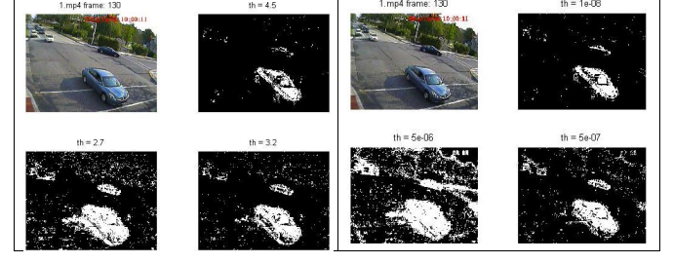

Fig.3.2 After Background Substraction

The most difficult part of the vehicle tracking task has turned out to be the segmentation phase. We have looked into two solutions to this issue so far. The first strategy uses a spatio-temporal analysis that was partially inspired by the pneumatic tube sensors that are already frequently employed for vehicle counts. In this method, we define a number of lines that serve as fictitious pneumatic tubes in the image, and we then measure the degree to which each of these lines is obscured by the regions left over after the background subtraction phase. The signals connected to each track are then subjected to a spatio-temporal analysis in order to look for patterns that correspond to the motion of moving vehicles across the image.

The fundamental plan is shown in Figure. Here, we can see the features that are being monitored, the background extraction procedure's blob detection, and the segmentation procedure's inferred groupings. By requiring that features that are grouped together move coherently over time, we are actively striving to improve the segmentation strategy.

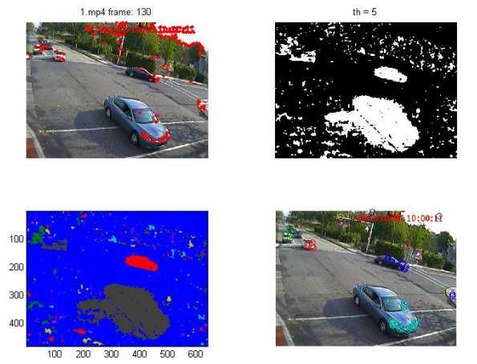

Fig.3.3 Features extractiona and grouping together

With the use of this knowledge, we can calibrate the camera to its best ability, allowing us to make inferences about how the cars are moving on the ground plane and how they might be blocking one another. An illustration of how such a calibration can be carried out using vanishing points connected to the roadway is shown in the image below.

**Chapter 4**

**Result and Discussion**

The camera had to be mounted on an overhead bridge directly above the route of traffic flow because the success of the project depended on having a sufficient line of sight for the camera view. This was done to reduce vehicle occlusion. Due to the country's security situation, testing were conducted using two video clips from the internet that were readily available, one with automobiles going away from the camera view and the other with vehicles moving toward the camera view.

The camera calibration, which is done to determine the projection matrix between the image coordinate and the world coordinate, lane selection, and tracking region all affect how accurate the findings are.To achieve the best results, the system has undergone testing with several camera calibrations.The video clips were put through a number of independent tests to carry out vehicle recognition, tracking, categorization, and counting in order to achieve the desired result.As might be expected, mistakes rise when the camera view's lanes are tilted. The established method has faults, particularly when the vehicles do not follow the chosen lanes and when tall vehicles frequently occupy the side lanes and block two lanes from the camera's view.

OUTPUT **BEFORE** VEHICLE CROSSES COUNTING LINE

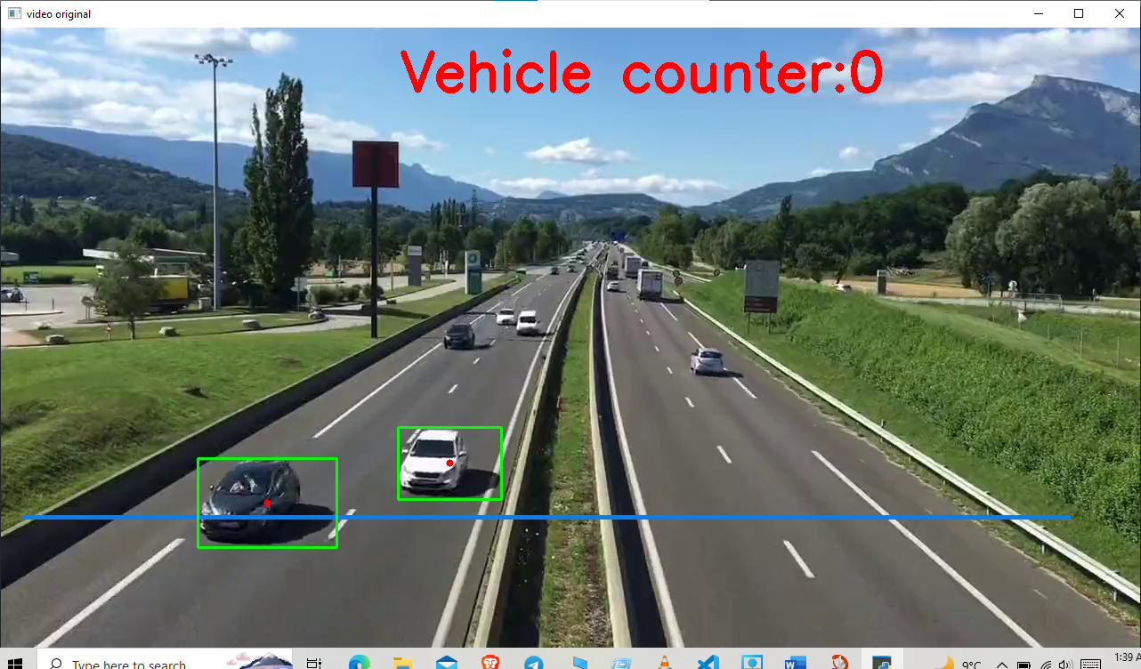

OUTPUT **AFTER** VEHICLE PASSES COUNTING LINE

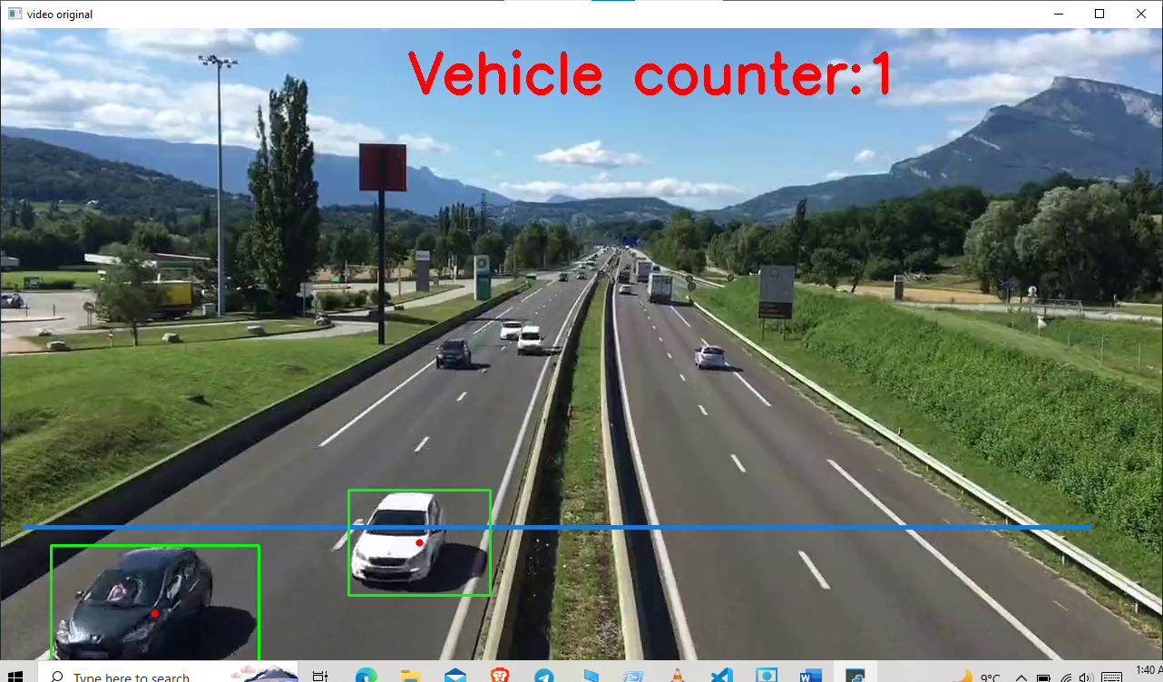

**Chapter 5**

**Conclusion and Future Work**

This research presents preliminary findings for constructing an automated system for counting and categorising automobiles in motion using image processing techniques. The created system had a fair degree of accuracy in its ability to monitor and categorise cars. The device can process real-time video clips of traffic scenes at a frame rate of 15 fps.

The system's results indicate that, with more advancements, it will be able to count and categorise automobiles on congested roads in real time. The system can function pretty accurately, especially if a view of the flow of the vehicles can be gained despite obstructions.

A working model to detect and count vehicles has been created and implemented.

**References**

[1] R. Chellappa “Vehicle detection and tracking using acoustic and video sensors”, 2004

[2] Sensor Line, Classax, Traffic Data Acquisition System, Germany, [www.sensorline.de](http://www.sensorline.de)

[3] S. Gupte, “Detection and Classification of Vehicles”, University of Minnesota 2002.

[4] E. Atkociunas, "Image Processing in Road Traffic Analysis", Vilnius University, 2005

[5] B. Coifman "A Real-Time Computer Vision System for Vehicle Tracking and Traffic Surveillance" University of California, 1998 [

6] C. Zhang "Adaptive Background Learning for Vehicle Detection and SpatioTemporalTracking", IEEE, 2003

[7] R. Cucchiara “Vehicle Detection under Day and Night Illumination" Proc. of ISCS-IIA, Special session on vehicle traffic and surveillance, 1999

[8] Z.W. Kim "Fast Vehicle Detection with Probabilistic Feature Grouping and its Application to Vehicle Tracking", CiteSeer, 2001